

PCIC EUROPE COPYRIGHT FORM

TITLE OF PAPER:_________________________________________________________
______________________________________________________________________

LIST OF ALL AUTHORS:_____________________________________________________
______________________________________________________________________

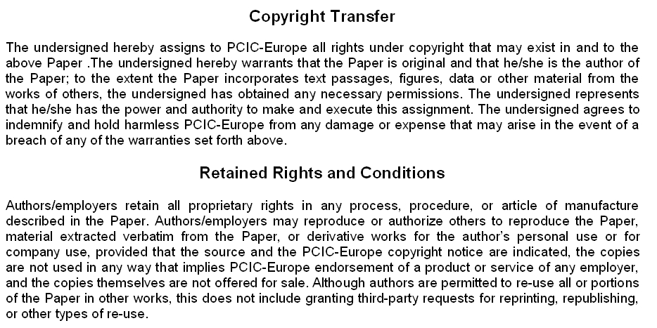

__________________________________________________ _______________
Signature of Author/Authorized Agent for Joint Authors Date

